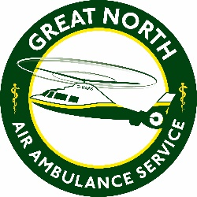
The Great North Air Ambulance Service
Person Specification
JOB TITLE: Coffee House Assistant
DEPARTMENT: Hanger 63 Coffee House
 | Essential | Desirable
Qualifications/Education/  Training | Minimum of 3 GCSE’s grade C and above including English and Maths or equivalent  Holds a current clean driving licence | Level 1 Award in food safety and catering and Manufacturing.
Experience | Experience of working in a coffee house  Experience of working in a fast-paced and customer focused environment
Skills/Knowledge | Strong customer service skills  IT skills  The ability to implement and follow processes  Numeracy skills  Strong organisation skills, able to deal with and prioritise a range of tasks  Ability to work both as part of a team and on own initiative when working independently  Able to take on manual handling tasks associated with working in a coffee house | Knowledge of health and safety  Baking Skills
Personal Characteristics/  Communication | Self-motivated  Excellent interpersonal skills, ability to communicate with a broad range of people both verbally and in writing.  Flexible, able to work early mornings, evenings and weekends as required  Passionate about working for GNAAS

