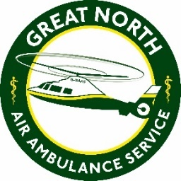
The Great North Air Ambulance Service
Job Description

Job title: Cook
Main purpose of job: To prepare food and drink items for the Coffee House customers

Role Summary: You will be providing heated food to the customers of the coffee house and maintaining health and hygiene standards, as well as serving customers and helping assist in training of new volunteers and employees.

Main Tasks of Role:
- Prepare meals and drinks adhering to the charity’s Coffee House policies and recipes
- Maintain Health and Hygiene standards in all areas of the Coffee House.
- Ensure that the prep area and kitchen is cleaned and sanitised at the end of each shift including emptying all bins.
- Maintaining a pantry stock record. Rotating stock items as per use by date.
- Ordering new ingredients as required to ensure minimum stock levels and restocking the pantry/store area.
- Complete daily/weekly checks as required for cleaning schedules, fridge/freezer temp checks, food temp checks and facility checks.
- Check and accept deliveries and maintain supplier tracking records.
- Maintain Level 2 (as a minimum) Award in Food safety and Catering and Manufacturing.
- Assist in the continuous development of the offered menu including portion sizes and costing.
- Communicate in a courteous and professional manner with members of the public/supporters.
- Accurately complete all relevant paperwork.
- Comply with all health and safety policies and procedures.
- Assist in induction training of new team members as required.
This list is not exhaustive

