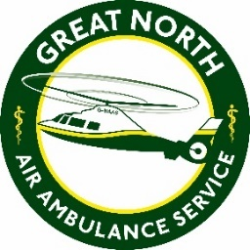
The Great North Air Ambulance Service
Job Description

Job title: Coffee House Assistant
Main purpose of job: To help run the shopfloor on a day-to-day basis in Hangar 63 and assist the volunteers.

Role Summary
Greeting customers and serving coffee and baked goods, ensuring the smooth running of the coffee house and making sure the maintenance and cleanliness is of a high standard.

Main tasks of job:

- Prepare drinks adhering to the charity’s Coffee House policies
- Take food and drink orders, the accurate use of the Coffee House ordering system and use of the computerised till and payment system
- Serve drinks and meals at both counter and tables.
- Clear and clean tables
- Assist the volunteers working in Hangar 63
- Cash handling and cashing up the till
- Maintain Health and Hygiene standards in all areas of the Coffee House
- Communicate in a courteous and professional manner with members of the public/supporters
- Assist in the re-stocking and display of shop stock practising good stock rotation
- Accurately complete all relevant paperwork.
- Comply with all health and safety policies and procedures
- Assist in induction training of new team members as required

This list is not exhaustive

