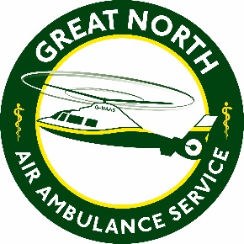
The Great North Air Ambulance Service
Job Description

Job Title: Conferencing Assistant
Main Purpose of the job: The conferencing department offers conferencing facilities for both internal and external bookings to raise income for the charity.
The postholder will be responsible and accountable for providing customer service and administrative support to the commercial project team and across the wider charity.
The postholder may be required to work early mornings (8am start) and evenings (latest 9pm) as part of their 20 contracted hours. Weekend work may also be required. We aim to give team members at least three weeks’ notice of their hours where possible.
Relationships:
- Responsible to: | Commercial Project Manager
- Liaise with: | Donors, suppliers, general public, and charity employees/volunteers.
Location: Progress House, Urlay Nook Road, Eaglescliffe, Stockton-on-Tees, TS16 0QB
Hours: Part-time, 20 hours over 3 days per week (to be worked flexibly including early mornings and evenings as required)
Contract Type: Part-time, permanent.
Salary: Band 1 £XXXXXX per annum, pro-rata.
Main Duties and Key Responsibilities
- Assist the commercial project team to provide a professional and efficient conferencing support at the charity’s Head Office.
- Assist the commercial project team and wider team with external room bookings as required, including setting up and tidying meeting rooms, serving and catering required, and liaising with delegates whilst on site.
- Respond to all enquiries relating to room bookings in a courteous and professional manner, in person, on the telephone or via email.
- Responsible for consumables, stock control and co-ordination of deliveries and orders within the conferencing dept.
- Responsible as part of the wider team to open and close Head Office. Ensure the main entrance is open for core hours and facilities bookings, as well as disarming/activating alarms when necessary.
- Work within any health and safety requirements and charity policies.
- Attend training to develop skills and knowledge as necessary.

The above is not an exhaustive list of duties and you will be expected to perform different tasks as necessitated by the organisation and the overall business objectives.

Signature............................................

Date.....................................................

