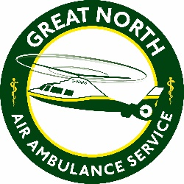
The Great North Air Ambulance Service
Person Specification

JOB TITLE: Fundraiser - Isle of Man
DEPARTMENT: Income and Engagement
 | Essential | Desirable
Qualification/Education/  Training | Minimum of 5 GCSE’s grade C and above including English and Maths or equivalent.  Current clean driving licence (the role involves business travel).  Enhanced DBS Certificate. | Degree qualified or equivalent.  Fundraising Qualification.
Personal Characteristics/ Communication | Self-motivated.  Ability to work well under pressure.  Confident public speaker and outstanding communication skills, both verbally and in writing.  Thrives around people building beneficial relationships.  Natural storyteller.  Excellent interpersonal skills and ability to communicate with a broad range of people.  Flexibility to work unsocial hours, including weekends and evenings, and to travel as required.
Skills/Knowledge | Computer literate and experience of using Microsoft Office particularly Word, PowerPoint and Excel  Strong customer service skills and understanding of the importance of customer/donor retention.  Ability to promote the charity face to face and using telephone and email.  Presentation skills and a confident public speaker.  Strong organisation skills and a proven ability to meet deadlines whilst maintaining attention to detail.  Ability to produce written reports and analyse supporter data. | Knowledge of the legal framework applicable to charity fundraising
Experience | Minimum of 2 years’ experience in an industry with skills transferrable to not-for-profit sector.  Proven track record of meeting and/or exceeding targets.  Demonstrable experience of building successful ongoing relationships.  Experience of using a CRM system. | Fundraising experience.  Sales experience.

