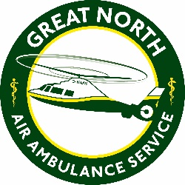
The Great North Air Ambulance Service
Person Specification

JOB TITLE: Business Support Assistant, IT (9-month fixed term contract)
 | Essential | Desirable
Qualifications/ Education/ Training | Minimum of 5 GCSE’s grade C and above including English and Maths | Science and/or Maths A levels of other higher-level qualification
Experience | Computer hardware assembly and connection, software installation. This experience doesn’t need to have been gained in a professional setting if adequate personal project work of educational experience can be demonstrated | Windows and Linux, creation of simple databases and more advanced Excel use
Skills/Knowledge | Highly computer literate with experience of using Microsoft Office particularly Word, PowerPoint and Excel.  Able to create presentations and reports based on multiple data sets. | Ability to create a relational database, with an understanding of SQL.
Personal Characteristics/ Communication | Ability to communicate complex topics in language and words that enable less technical colleagues to understand  Excellent interpersonal skills and the ability to communicate with a broad range of people.  Attention to detail when resolving issues and recording actions to ensure records are accurate and up to date.

