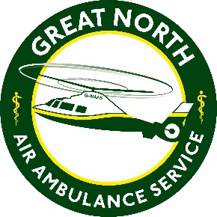
The Great North Air Ambulance Service
Job Description
Job Title: Business Support Assistant, IT
Main Purpose of the job: Responsible and accountable for providing IT support to end-users, administration of business applications.
Relationships:
- Responsible to: | Head of IT
- Liaise with: | Employees, contractors, volunteers
Location: Progress House, Urlay Nook Road, Eaglescliffe, Stockton-on-Tees, TS16 0QB
Hours: 40 per week (includes evenings and weekends)
Contract Type: Fixed Term – the position will initially be offered on a 9 months fixed term contract.
Salary Range: £18,138- £18,738 (Band 1)
Main Duties and Key Responsibilities
- Ensure that all IT fault cases are recorded promptly and efficiently and managed to completion.
- Support conference facilities users with guidance and resolution of any issues experienced with using the GNAAS provided equipment
- Maintaining asset records in line with agreed processes and undertaking general administration duties.
- Conducting regular audits and routine checks and maintenance of systems to proactively ensure a high level of service and quality
- Manage the process of cleansing data against PAF files, deceased, TPS, MPS. Develop and maintain systems and processes in line with best practice and legislative requirements.
- Maintaining records in line with agreed processes and undertaking general administration duties.
- Assist the Departments Heads of Service and Managers as necessary and take on duties as required.
- Attend training to develop skills and knowledge as necessary.

Additional to the main focus of the role above, cover within the business support department will involve the following responsibilities on an ad-hoc basis;
- Ensure enquiries from reception and relating to room bookings are responded to in a prompt, professional and courteous manner, in person, on the telephone or via email.
- Undertake general administration duties to support the effective operation of the charity.
- Assist the Head of Facilities with conferences as required, including; setting up of and derigging of rooms, dealing with arrangements for external catering, liaising with customers whilst on site, and assisting with the digital setup of the AV equipment.
- Responsible for consumables orders, stock control and co-ordination of deliveries and orders.
- Manage, organise and update data on electronic databases.

The above is not an exhaustive list of duties and you will be expected to perform different tasks as necessitated by the organisation and the overall business objectives.

